***Dominating Set is NP-Complete – proof***

The in-class exercise was too hand-wavy. Basically, to formalize the proof that the Dominating Set problem is NP-Complete, it’s necessary to remember that the exact definitions of the dominating set and vertex cover problems.

D(G,n) is the problem of determining whether a graph G = (V,E) has a dominating set of size n.

V(G,m) is the problem of determining whether a graph G has a vertex cover of size m.

To prove Dominating Set is NP-Complete, I follow a 4-step process.

1. Prove that D(G,n) is in NP. This is pretty simple. For a graph G, the certificate is the set of vertices in the dominating set, call it VD. O(V) First verify that there are n vertices in GD. (at worst O(V)) Then iterate through all the vertices in VD, marking off the vertex itself and any vertices that are adjacent to it (via an edge). (At worst O(V+E), since we iterate through at most V vertices and check each edge at most twice.) Then iterate through the vertices again to check that all are marked. (O(V)). If so, return truel else, return false.
2. This is the tricky part. We need to convert graph G=(V,E) into a graph G’=(V’,E’) – where G’ may be the same graph as G – so that the following two conditions hold:
   1. In step 3, given a dominating set GD of size n in graph G, we can use it to find a vertex cover G’C of size m for graph G’ in polynomial time.
   2. In step 4, given a vertex cover G’C of size m in graph G’, we can use it to find a dominating set GD of size n for graph G in polynomial time.

T do this, for each edge e between vertices a and b in G, add a new edge e’ in G’ between vertices a and b, and stick a new vertex ab’ in the middle of it. Here’s an example.

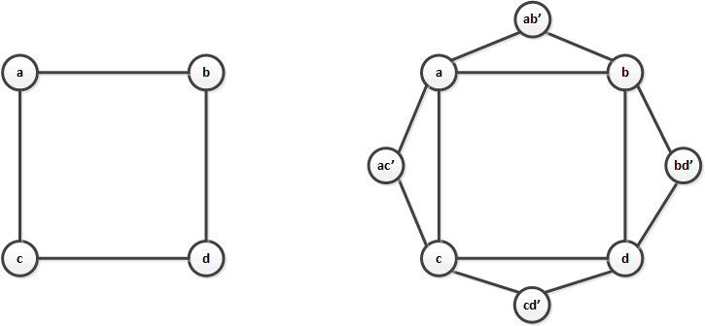

1. Now we show that a dominating set of size k in graph G’ can generate a vertex cover of size k in graph G. Notice that graph G’ was created from graph G by the addition of a number of triangles. Any vertex in the triangle dominates all three vertices in the triangle. Either of the two vertices that were carried over from graph G also covers the edge of the triangle that was in both graphs G and G’. You can pick a set of vertices that dominates each vertex of G’ from among the set of vertices common to both G and G’. It will cover all the edges in G’ as well, except for some edges incident on the newly created vertices. So it will cover all edges that were originally in G. So the same set of vertices forms a vertex cover of size k in G.
2. Now we show that a vertex cover of size k in graph G can generate a dominating set of size k in graph G’. A vertex cover of G covers all the edges E∈G. When creating graph G’ we added new vertices that were not present in G, but each new vertex v’ ∈ V’ is adjacent to the vertices at both ends of some edge e ∈E. Call those vertices v1 and v2, both in V. At least one of v1 and v2 is in the vertex cover of G. So that vertex cover is a dominating set of G’. The only subtlety here is that if graph G has isolated vertices (not connected to the rest of the graph by any edges) those vertices have to be added to the dominating set for G’.[1]

References:

This answer is sort of a compendium of information from these sources:

* <https://en.wikipedia.org/wiki/Vertex_cover>
* <https://en.wikipedia.org/wiki/Dominating_set>
* <http://www.cs.umd.edu/class/fall2017/cmsc451-0101/Lects/lect21-np-clique-vc-ds.pdf>
* <http://people.math.gatech.edu/~randall/Algs05/HW10_solns.pdf>
* <https://www.geeksforgeeks.org/proof-that-dominant-set-of-a-graph-is-np-complete/>

1. So if we wanted to be really precise we could say that the size of the dominating set induced by a vertex cover of size k on graph G is k + the number of isolated vertices in G.